Name : Tarisa Dwi Septia

NIM : 205410126

**MEETING 1**

Self-Introduction

1. 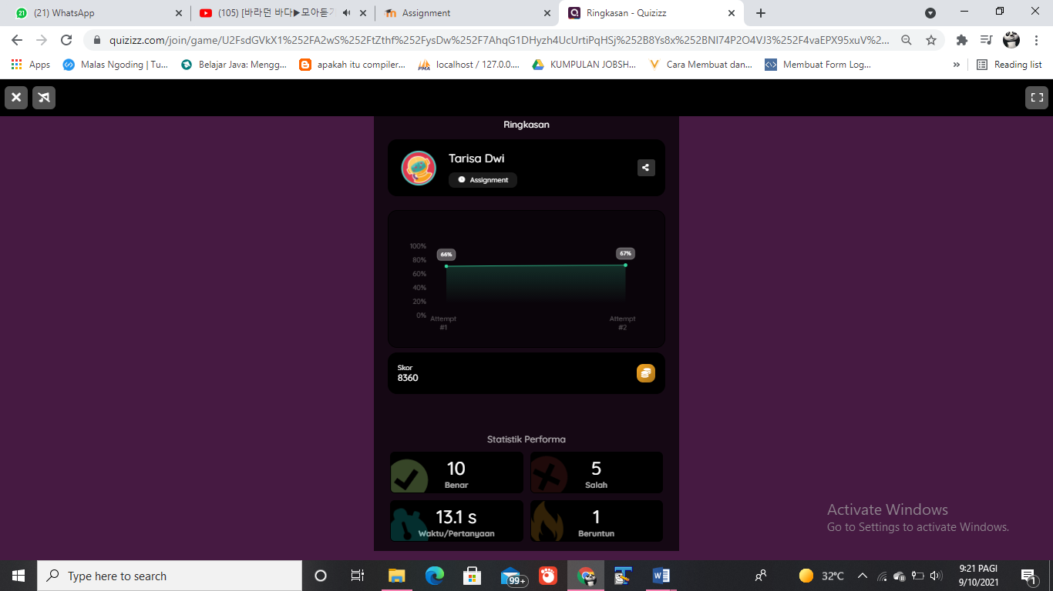Quis